January 25, 2021
West Salem Little League
4370712

We are pleased to inform you that the proposed Constitution of West Salem Little League has been found to be in basic agreement with Little League Baseball and Softball Rules and Regulations.

The proposed Constitution indicates that the document was presented to the league membership on, (10/5/2020). We respectfully suggest that copies of this document be made available to any regular member upon request. Reference to this document should be included in the notice to members of the annual meeting for reports, election of Board Members, and any special membership meetings that may be scheduled.

This copy of the League's Constitution, including approved changes, will be placed in the league's permanent file at the Regional Center. As always, if we can help with any league problem at any time, please let us know.

Best regards to the Board of Directors and Membership of your league for a safe and successful 2021 season.

Sincerely,
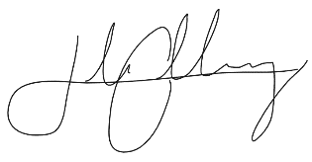
Jake Gallaway
West Region Coordinator
Little League Baseball and Softball

cc District Administrator
Cari Buchholz

